*This document should be inside the folder, “Building the hardware”

*All the necessary hardware parts that should be purchased are listed in “HIW3_Hardware_Assembly_Parts_2024.xlsx”

*The “Helpful_Documentations” folder within the “Building the hardware” folder contains things like spec sheets for 3-way final valve, cooldrive solo, and blackfly camera; templates for poke port, port adapter, and bottle holders; odor bottle making checklist

**<1-Box/8-Odor set-up, Without Vacuum>**

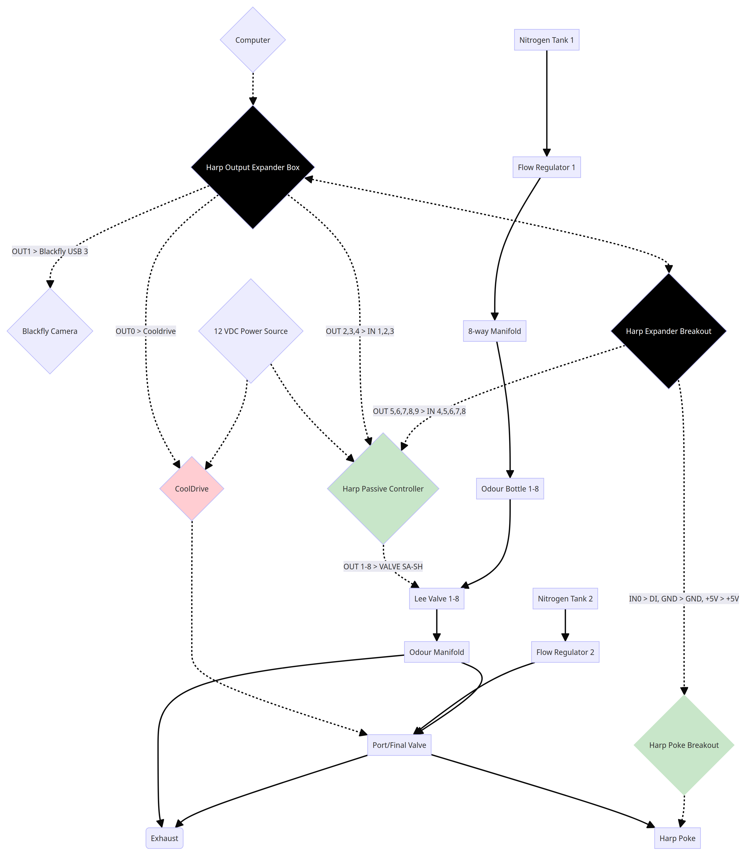

*Solid lines : tubings

*Dotted lines : wires­/cables

**<1 Box/7-Odor set-up, With Vacuum>**

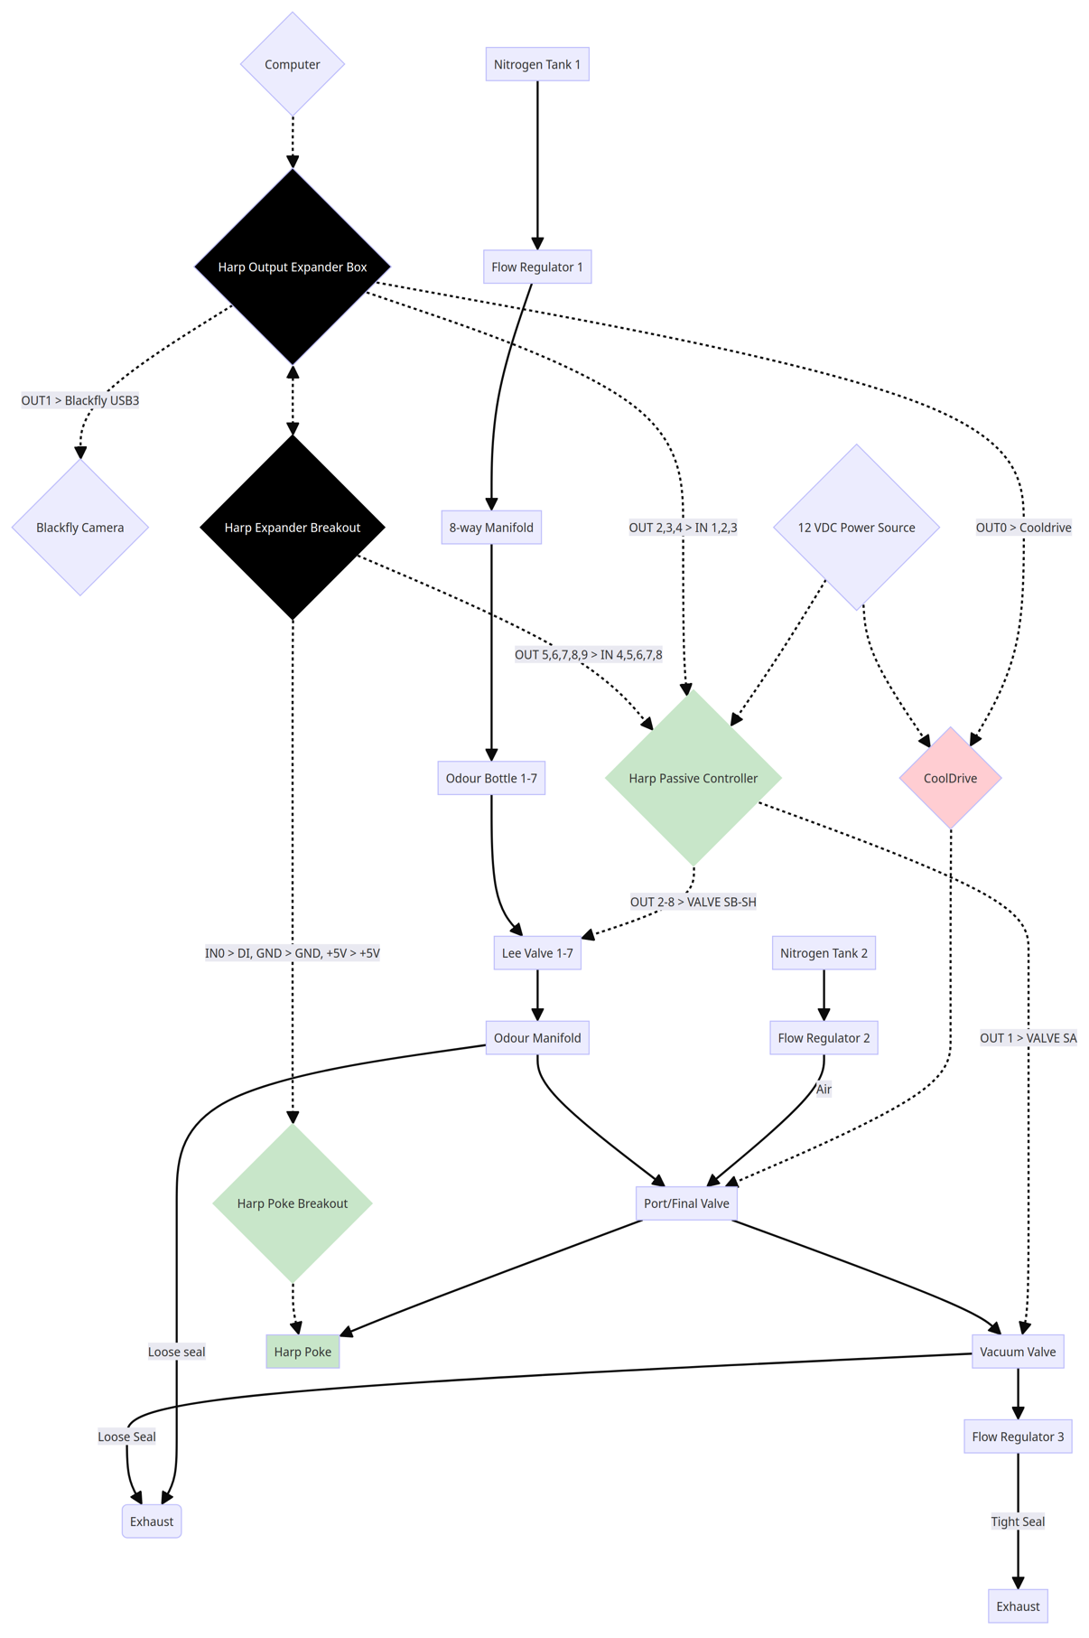

*Solid lines : tubings

*Dotted lines : wires­/cables

**Guideline – 1 box, 3 odors**

**Necessary Parts**

* Refer to the Excel document, “HIW3_Hardware_Assembly_Parts_2024”

**Rack Set-up**

* Attach pic of entire rack + info about box configuration

**Odor Bottles & Odorants & Holders**

* Refer to the document “Checklist_odor bottles_modified_HIW3.docx” (Created in 2020 by Ohashi, modified in 2024) and make a bulk of them (At least 32 if you’re running 4 cages * 8 odors)
* Current odorants in use are 100% Pinene, Isopentyl Acetate, and Limonene
  + **Do not use Octanal – it will evaporate and get into the tubing
* Label each bottle with tape; it’s better to use different colored tapes for different odorants so you don’t confuse them
* 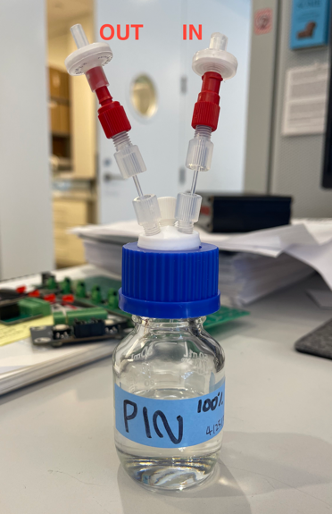 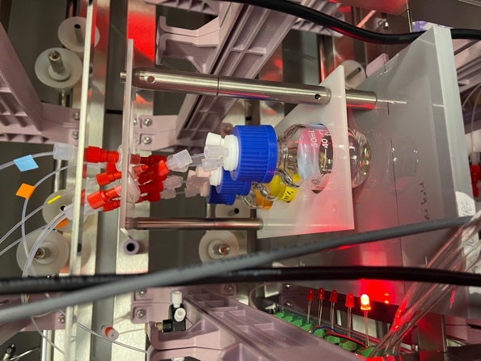
* For bottle holders, laser cut a 3/32” acrylic sheet using the template “HIW-acrylic-board_FINAL.ai”
  + The rectangle with bigger circles holds the luers/tubings in place.
  + The rectangle with smaller circles holds the bottles in place.
  + As shown in the above image, from bottom to top, assemble…
    - 30mm thorlab bar/optical post > 4mm set screw > acrylic sheet with small circles > 75mm thorlab bar > 6mm set screw > 50mm thorlab bar > acrylic sheet with bigger circles > 4mm cap screw
    - 2 thorlab bar pillars are enough to hold the acrylic sheets in place.

**Cage Modification**

* The cage Zuckerman Institute uses is Allentown’s NexGen Mouse 500 (Edge Cage)
* The External Bottle top was replaced with the Micro Barrier Top so the space that the water bottle goes in doesn’t get in the way of the camera
* 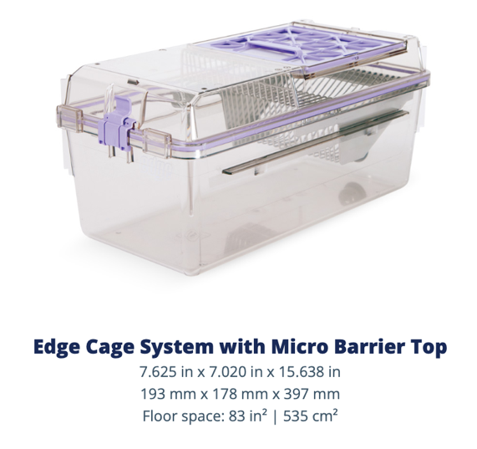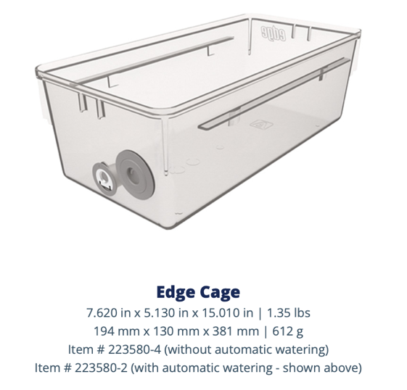
* With the cage facing the front, Zuckerman’s machine shop carved out (1) a square where the poke port and its adapter goes into (2) two circle holes where the screw goes in to hold the poke port/adapter in place
  + Attach cage pic
* Attach dimension info from Chaim

**Poke Port**

1. 3D-print the poke port adapter with PLA material using the “Harp-Poke_adaptor_FINAL” file (available as SketchUp document and stl file)
2. Machine the poke port with aluminium and anodize it
   1. At Zuckerman Institute, Tanya Tabachnik machined it in-house and sent it to Jupiter, FL for anodizing
   2. Attach blueprint + add it to the folder as well
3. Attach the adapter to the poke port with M3 screws
4. Attach the port circuit board to the poke port with M3 screws
5. Using an epoxy glue (or any glue that’s strong enough), glue the spout to the assembled poke port (make sure the end of the spout is flushed to the metal port’s odor delivery hole)
6. 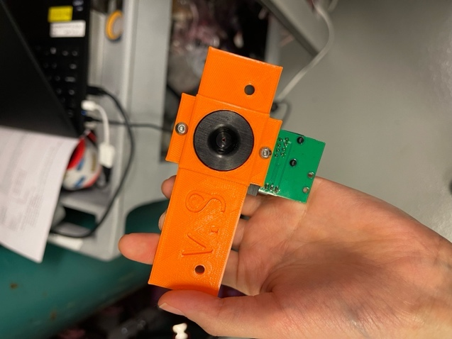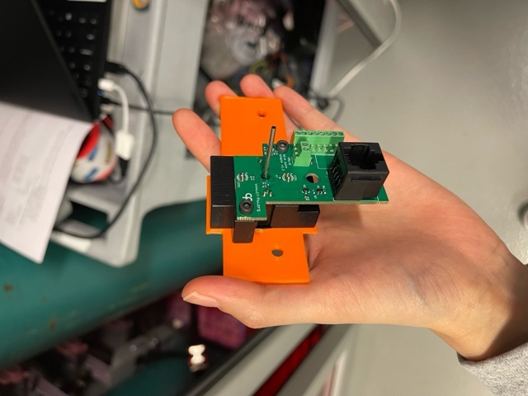 > Final product

**Soldering cables – Camera, final valve, cool drive**

1. Solder the GPIO cable (for Blackfly camera) to a BNC cable
   1. GPIO’s **BLUE** cable 🡪 BNC cable’s ground
   2. GPIO’s **BLACK** cable 🡪 BNC cable’s trigger
   3. ***It’s counterintuitive! Don’t mix them up!
   4. 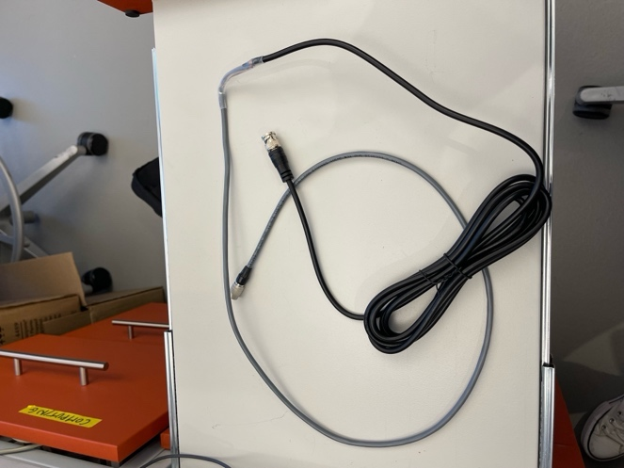
2. Solder 2 rainbow cables (female ends) to the final 3-way valve cables. These will connect to the CoolDrive.
   1. 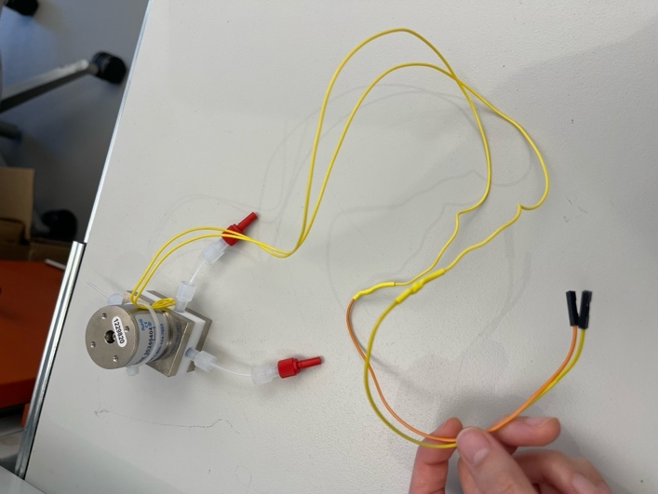
3. Solder 2 rainbow cables (red and black, female ends) to a DC extension cable. This will be used to provide power to CoolDrive.
   1. Red rainbow cable 🡪 Red cable inside DC extension cable
   2. Black rainbow cable 🡪 Black cable inside DC extension cable
   3. 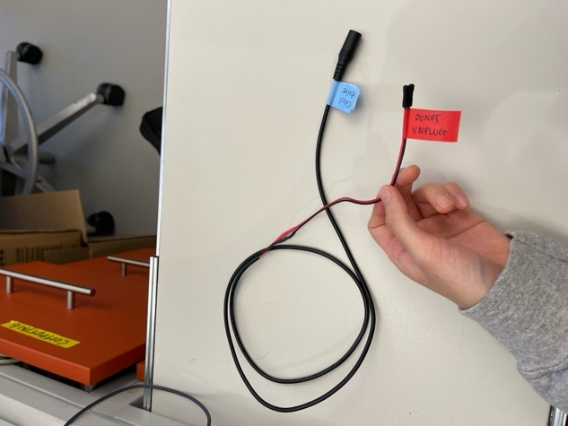
4. Solder 2 rainbow cables (white and black, female ends) to a BNC cable. This will connect the Output Expander (black HARP box) to CoolDrive.
   1. 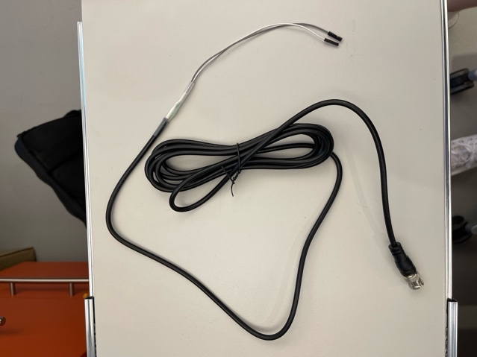
   2. White rainbow cable 🡪 BNC cable’s trigger
   3. Black/grey rainbow cable 🡪 BNC cable’s ground
5. **(VACUUM MODE)** Solder BNC cable with 2 rainbow cables (white/black, male ends). This will connect the HARP output expander box (out 2) to the valve passive controller for the vacuum function.
   1. 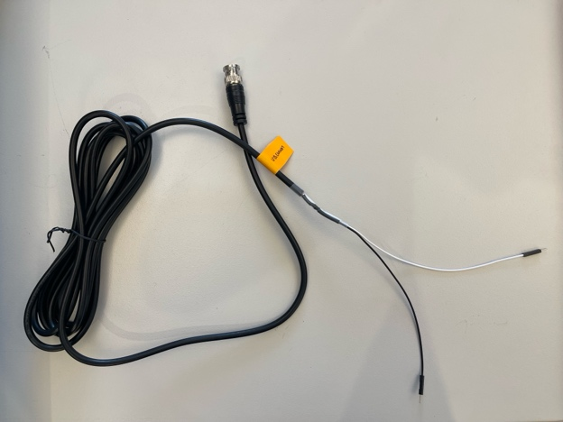
   2. White rainbow cable 🡪 BNC cable’s trigger
   3. Black rainbow cable 🡪 BNC cable’s ground

**Assembly**

1. Prepare
   1. Harp Output Expander (Black box)
   2. Harp Expander Breakout (Black board)
   3. Harp Valve Passive Controller (Big green board)
   4. Harp Behavior – Breakout (Small green board)
   5. Harp Behavior – Mice Poke with 3D (Green board where the poke port gets attached)
2. Connect *Harp Expander Breakout* to *Harp Behavior – Breakout* with hookup wires
   1. 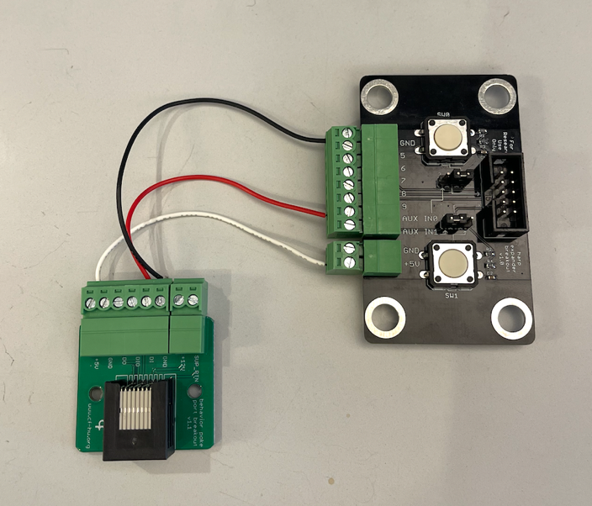
   2. Use different colored wires to distinguish them easily

|  |  |
| --- | --- |
| **Expander Breakout** | **Behavior Breakout** |
| GND | GND |
| AUX IN0 | DI |
| +5V | +5V |

1. Connect *Harp Expander Breakout* to *Valve Passive Controller*
   1. Assuming you’re using 3 odors…

|  |  |
| --- | --- |
| **Expander Breakout** | **Valve Passive Controller** |
| GND | GND (Any) |
| 5 | Valve 2 |
| 6 | Valve 3 |
| 7 | Valve 4 |

* 1. Disclaimer: all the grounds on Valve Passive Controller are connected with each other, so you only need to connect to one of them.
  2. Disclaimer: Valve 1 on Valve Passive Controller is used for vacuum
  3. 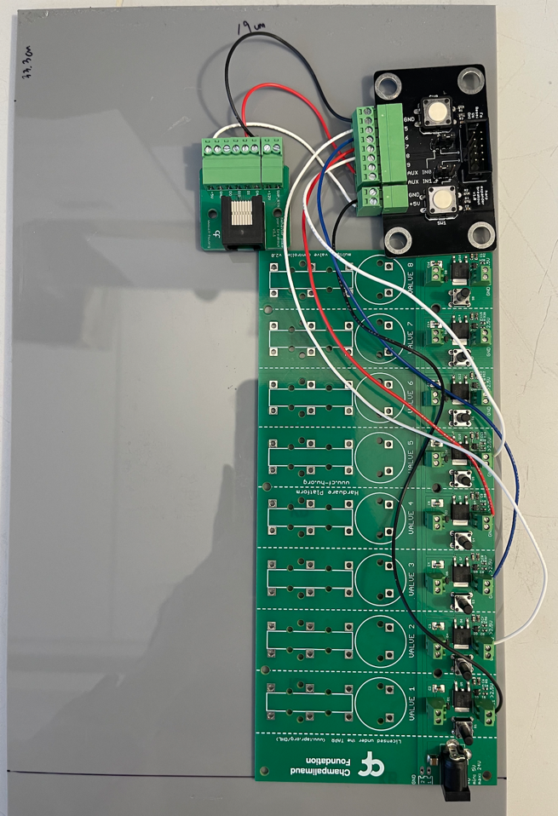

1. Fix the 3 boards in place by drilling holes in the acrylic board and using cap screws and nuts
   1. Valve Passive Controller, Behavior Breakout have M3 holes
   2. Expander Breakout has M6 holes
2. Assemble the 8-way blue manifold
   1. Get 8 valves (LHDA1223411H), blue 8-way manifold (LFMX0510538B), 9 mounting screws (LHWX0213420A), and 3 white screw support brackets (LHDX0307130A) - all from Lee Company)
   2. 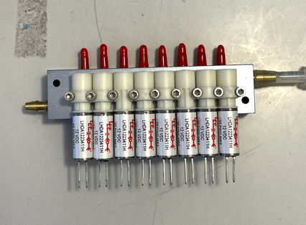 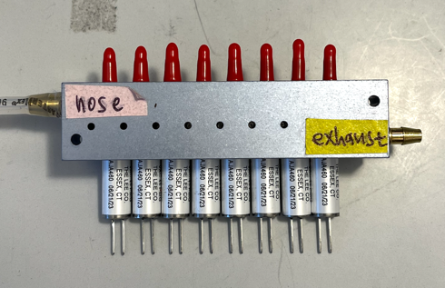
   3. Making sure the orientation is the same as the above images, place 3 valves on the manifold first and fix them in place with screws and brackets. Repeat for the rest of the valves.
   4. From the above image, note which end of the manifold goes to the port/nose and which goes to the exhaust.
3. Connect the assembled 8-way manifold to the Valve Passive Controller using rainbow cables
   1. 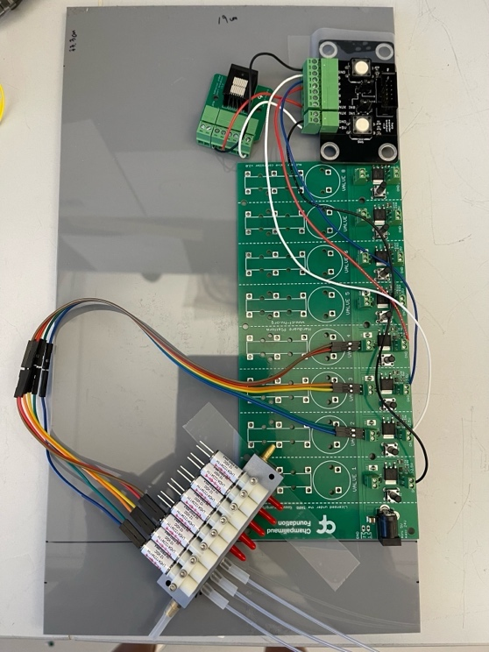
   2. Warning: don’t force-push the rainbow cables to the Lee valves – the 2 ends of the valves bend easily. Be careful.
4. Connect tubings/luers to the 8-way manifold
   1. Long tubings with female luers at the end will be connected to the bottles
   2. The short tubing with a transparent nut at the end will be connected to the 3-way final valve
      1. There is a set length to this tubing (87mm). Refer to the “3-way tubing guide” for the tubing length template.
   3. 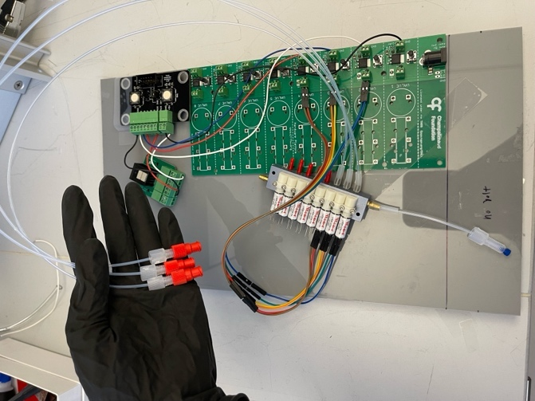
5. Add appropriate tubings to the final 3-way valve and connect it to the manifold.
   1. 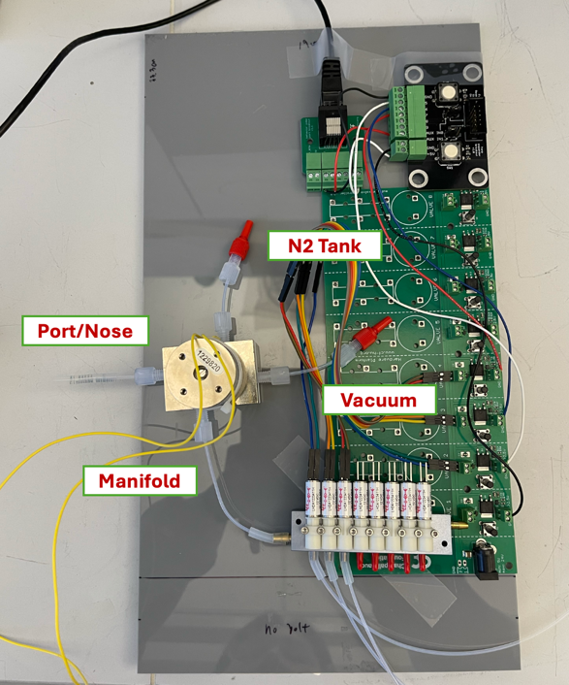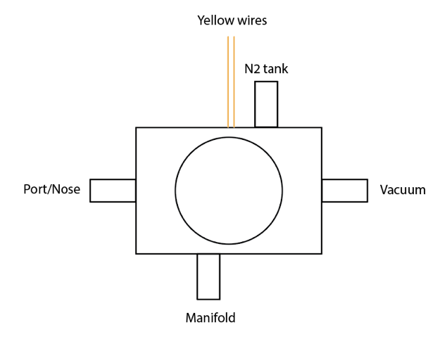
      1. For the configuration of the final valve, use the location of the yellow wires to avoid confusion!
      2. ***The tubing that goes to the port/nose has a set length (43mm). Refer to the “3-way tubing guide” for the tubing length template.
6. Connect the poke port to the Behavior Breakout using a 1.5 ft ethernet cable and connect the final 3-way valve to the poke port
   1. 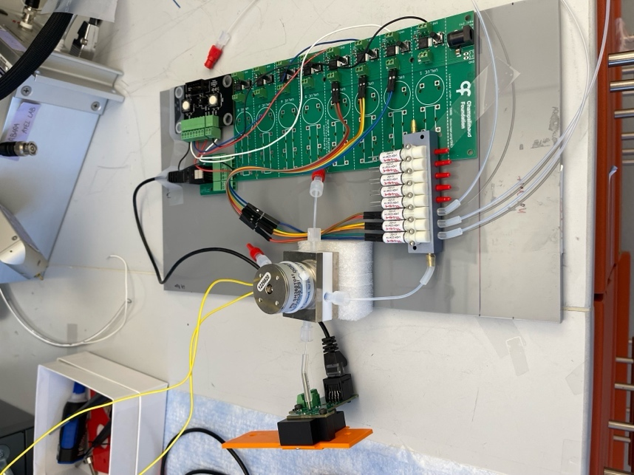
   2. Notice the sponge below the final 3-way valve used to dampen the valve clicking sound.
7. Assemble the 8-way air manifold (Idex Manifold) and connect it to the bottles
   1. Tubing on the top is getting air/N2 into the manifold, and the transparent nuts + tubings are carrying that air/N2 into the bottles
   2. 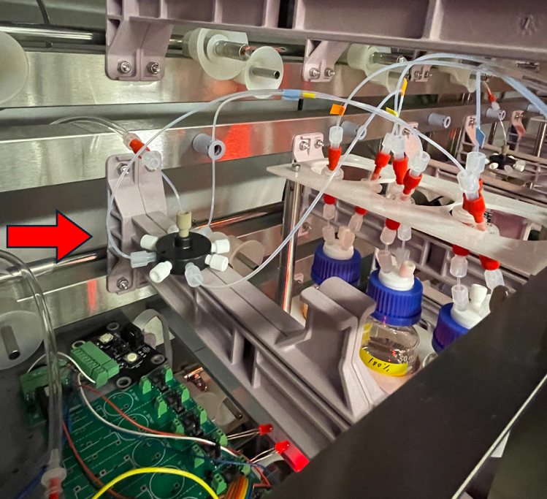
8. Connect the blue 8-way manifold (odor manifold) to the bottles
   1. 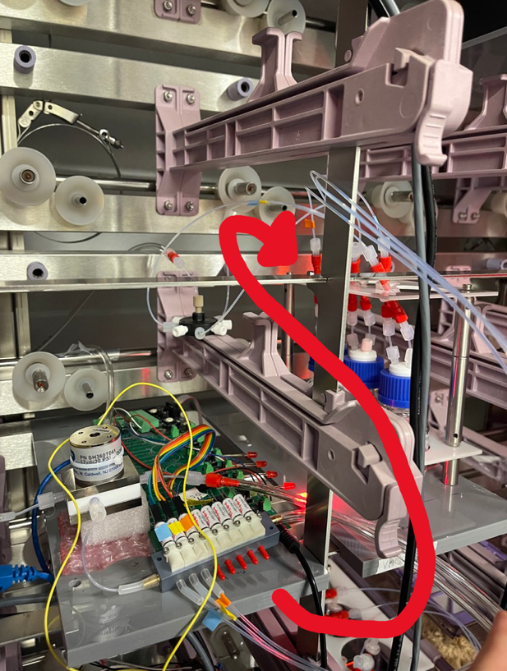
9. **(VACUUM MODE – Wiring)** Connect the HARP Output Expander “OUT 2” to Valve Passive Controller “Valve 1”
   * 1. You should make a custom cable for this – refer to the “**Soldering cables – Camera, final valve, cool drive”** section.
10. **(VACUUM MODE - Valve)** Connect the Lee Company valve (LHDA1233315H; notice that it’s a different type of valve than the ones on the blue manifold) to the olfactometer and connect the appropriate lines
    1. See below diagram. For the Lee valve,
       1. Top line: Normally open line. Loose connection to vacuum.
       2. Middle line: Common line. Connected to the final 3-way valve.
       3. Bottom line: Normally closed line. Connected to a 0.5 flow regulator and then tightly sealed to vacuum. (vacuum valve > flow reg. > vac). Turn the flow regulator up to max flow.
       4. 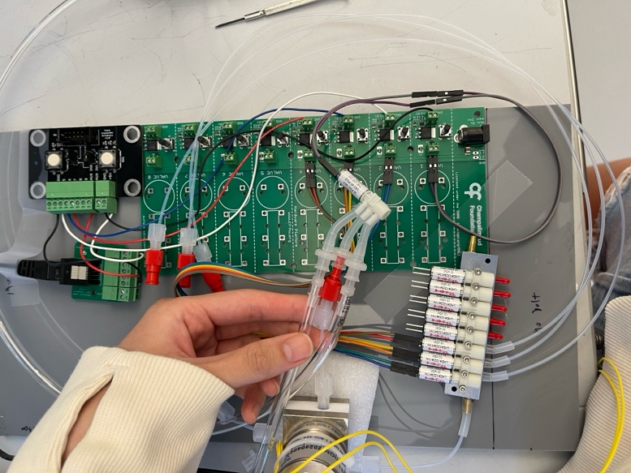
    2. 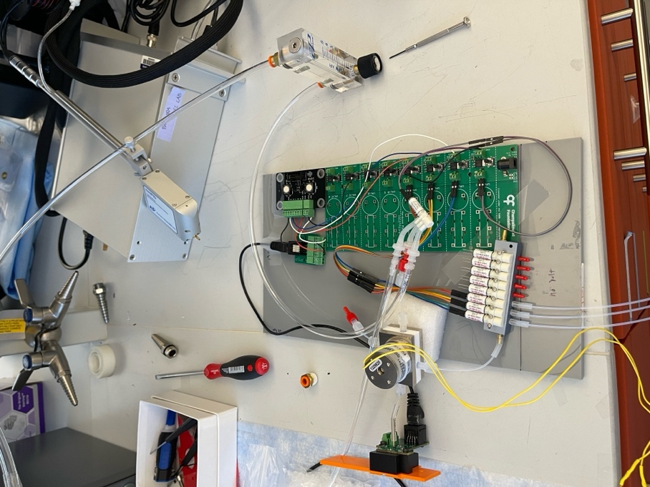
11. Connect the nitrogen tanks (M size) to the olfactometer
    1. Connect tank #1 to the final 3-way valve with an appropriate flow regulator/rotameter in between. 1 box, 3-odor setup requires air flow rate of 0.05 lpm (because we’re flowing 0.05 lpm per bottle).
    2. Connect tank #2 to the 8-way air manifold (Idex Manifold) so N2 goes into the bottles with an appropriate flow regulator/rotameter in between.
12. Connect the blue manifold to the vacuum (loose connection)
    1. Make sure you use a tubing that’s not porous or else it’ll leak all the smell!

**Cable connections**

1. Connect the HARP Expander Breakout to the HARP Output Expander Box with a ribbon cable
2. CoolDrive Solo (See attached spec file for this) connects to…
   1. Power source (12V)
      1. Pin #1: Positive line voltage
      2. Pin #2: Ground
      3. **IMPORTANT!! Do NOT pass logic to CoolDrive BEFORE it’s powered through the power source. IT WILL BREAK.**
   2. HARP Output Expander Box “OUT 0”
      1. Pin #3: Ground
      2. Pin #4: Trigger
   3. Final 3-way valve
      1. Pin #8 and #9 (Don’t need to distinguish)
   4. 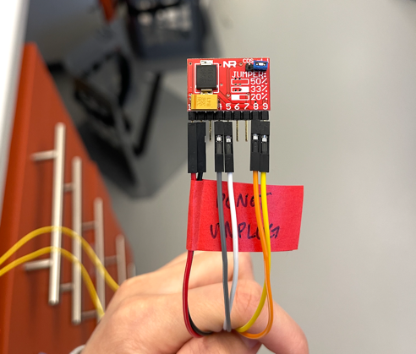
      1. You’re using the lines you soldered here. Refer to the “**Soldering cables – Camera, final valve, cool drive”** section.
3. Blackfly camera connects to…
   1. HARP Output Expander Box (use the GPIO – BNC cable you soldered) “OUT 1”
   2. Laptop (use the Type A-Male to Micro B cable)
      1. **IMPORTANT! Connect it DIRECTLY to one of the USB-A ports of the laptop. Do NOT use USB expander hubs for the camera. It will result in dropped frames.**
4. HARP Output Expander Box connects to the laptop (use the USB A to Mini B cable; use USB Expander Hub)
5. Power Source (12V) powers…
   1. CoolDriveSolo (connected in #2 of this section)
   2. HARP Valve Passive Controller
   3. IR source
   4. ***Use 8-way power splitter and multiple power sources if needed
6. Laptop is connected to the internet with the ethernet cable

**Flow regulators/rotameter**

* If you’re using Supelco rotameters (gives you an advantage of accurately dialing in low flow rate), make sure to use the “Flow Data” sheet that comes in the same box as the rotameters. The scale readings on the rotameters are NOT equal to the flow rate – it depends on the type of float as well as the rotameter model you’re using.

**<Model No: 22549> - The version that we’re using right now. Millipore sigma lacks stock for this particular model + it has a smaller range compared to the model below (23326).**

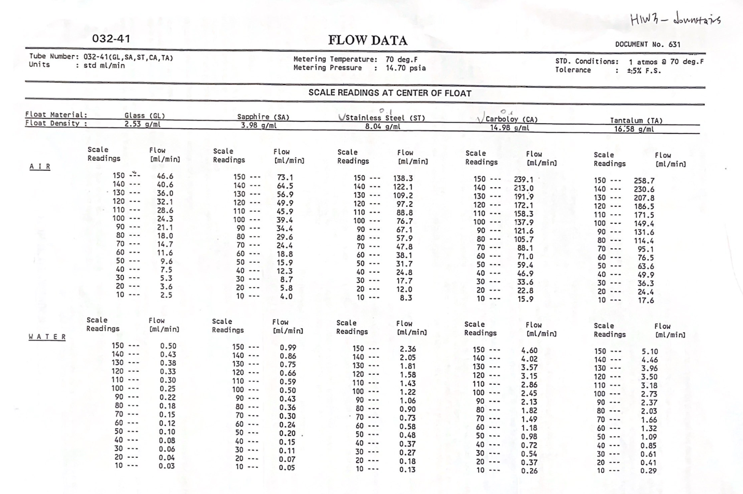

**<Model No: 23326> - The model in the hardware parts excel sheet. Use this instead of 22549 as this model has a bigger range.**

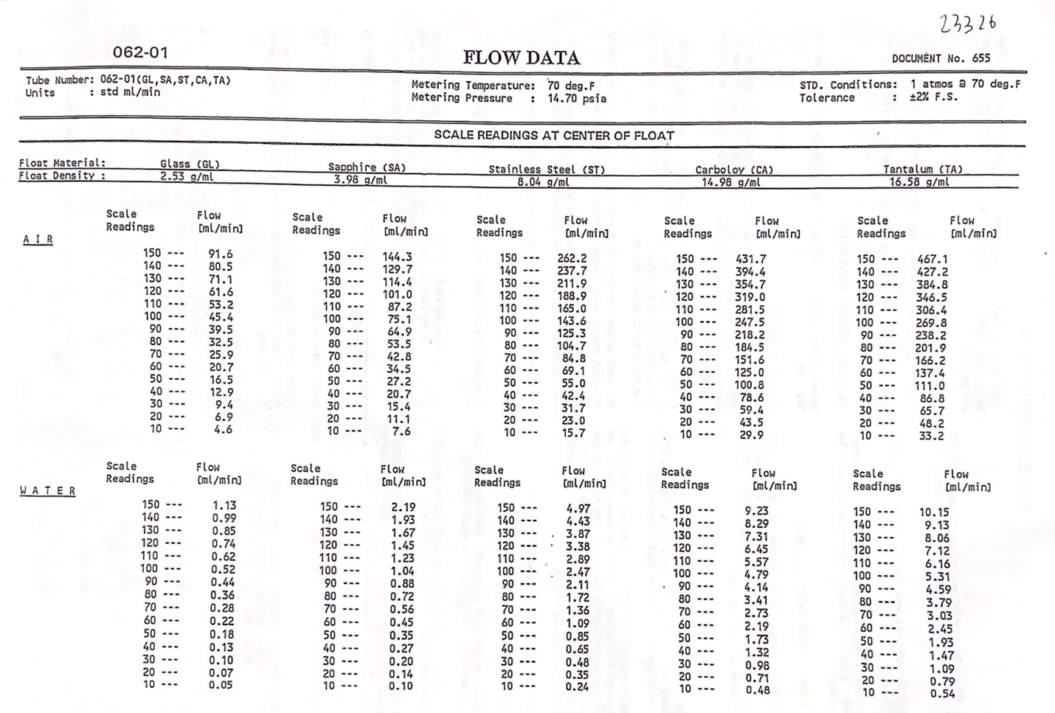

* With the current 4-box setup, the N2 lines are split as following:

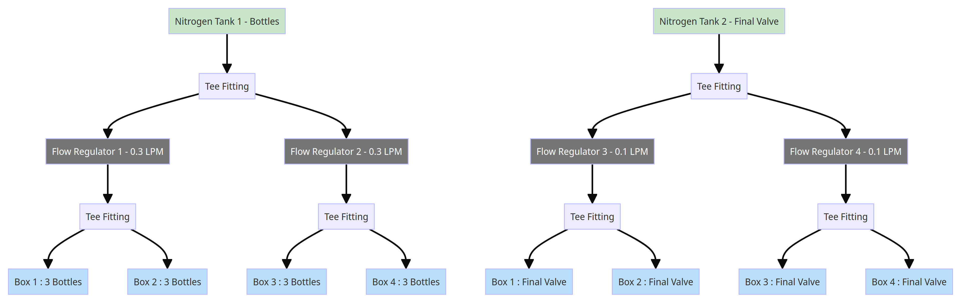

*0.05 lpm/bottle

*0.05lpm/final valve

* + Currently, flow regulator 1 and 2 are 0~0.5 lpm Cole-Parmer flowmeter (model no: FR2A12BVBN-CP, seems like it’s discontinued), and flow regulator 2 and 3 are Supelco Rotameter (model no: 22549)